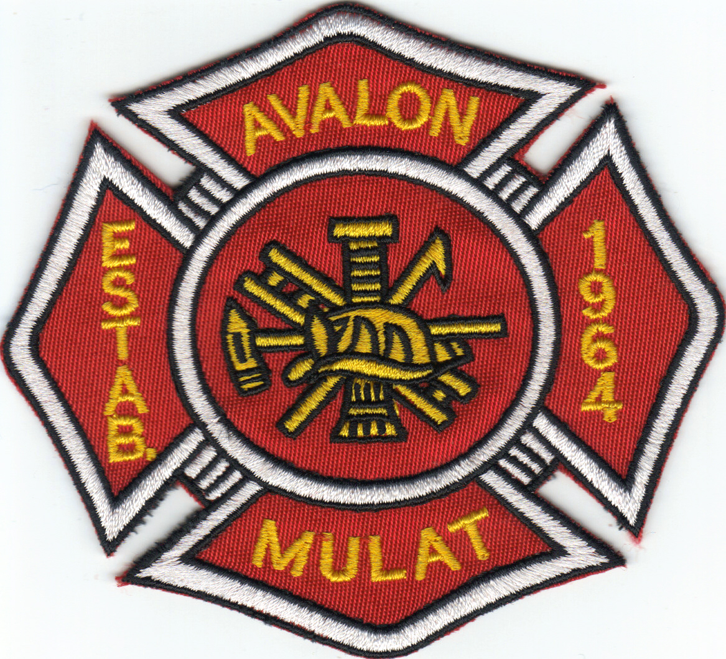 Avalon Fire Rescue 

Junior Fire Fighter
Release

I, ________________________________________________, being the parent or legal guardian of ___________________________________________, a minor, do herewith grant my permission for him/her to join the Avalon Fire Rescue, as a member of the Junior Firefighter program.

I also release the department from any liability in connection with any injuries he/she may sustain in connection with the performance of his/her duties, not covered by the department insurance.

Printed Name(s):__________________________________________________

Signature:_______________________________________________________

Dated: __________________________________

_______________________________________________
Notary Public

________________________________________________
My Commission Expires

Approved by: ________________________________________________
Chief

Date: __________________________________________

